1. 
2. 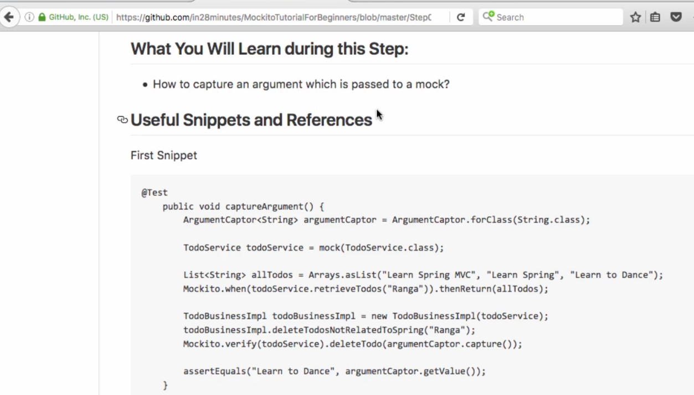
3. But let’s take a diversion.
4. In last lecture, we saw how to verify a method call on mock object.
5. Let’s write the same in BDD style.  
   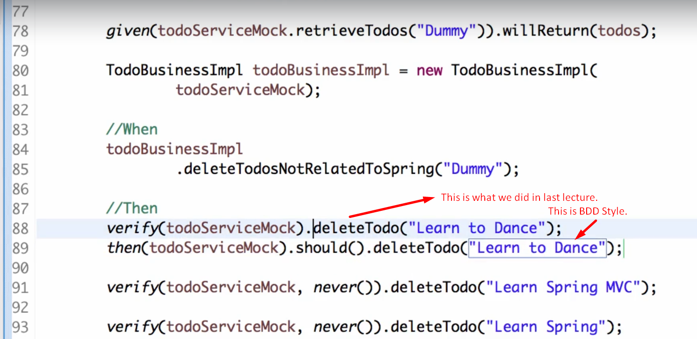
6. 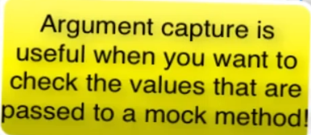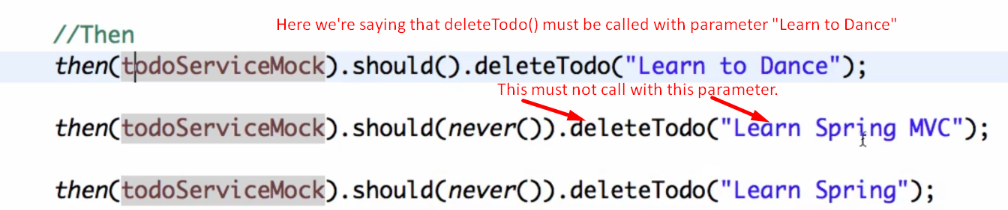
7. 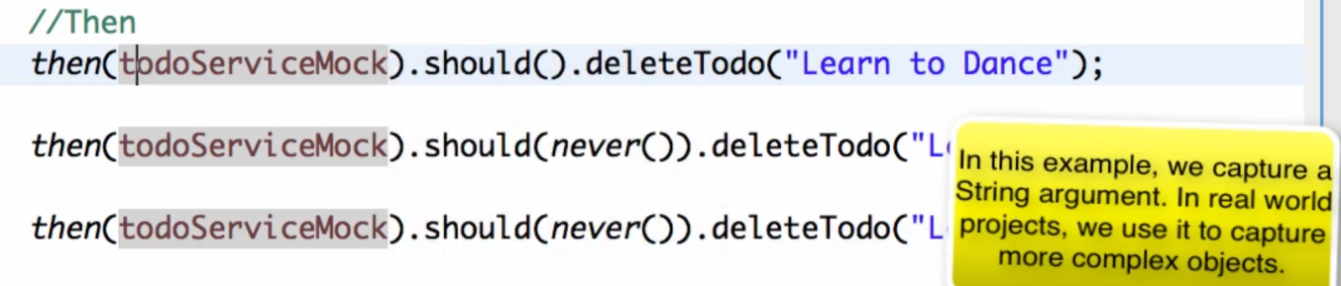
8. 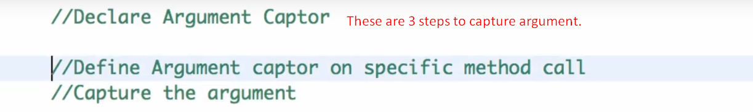
9. 